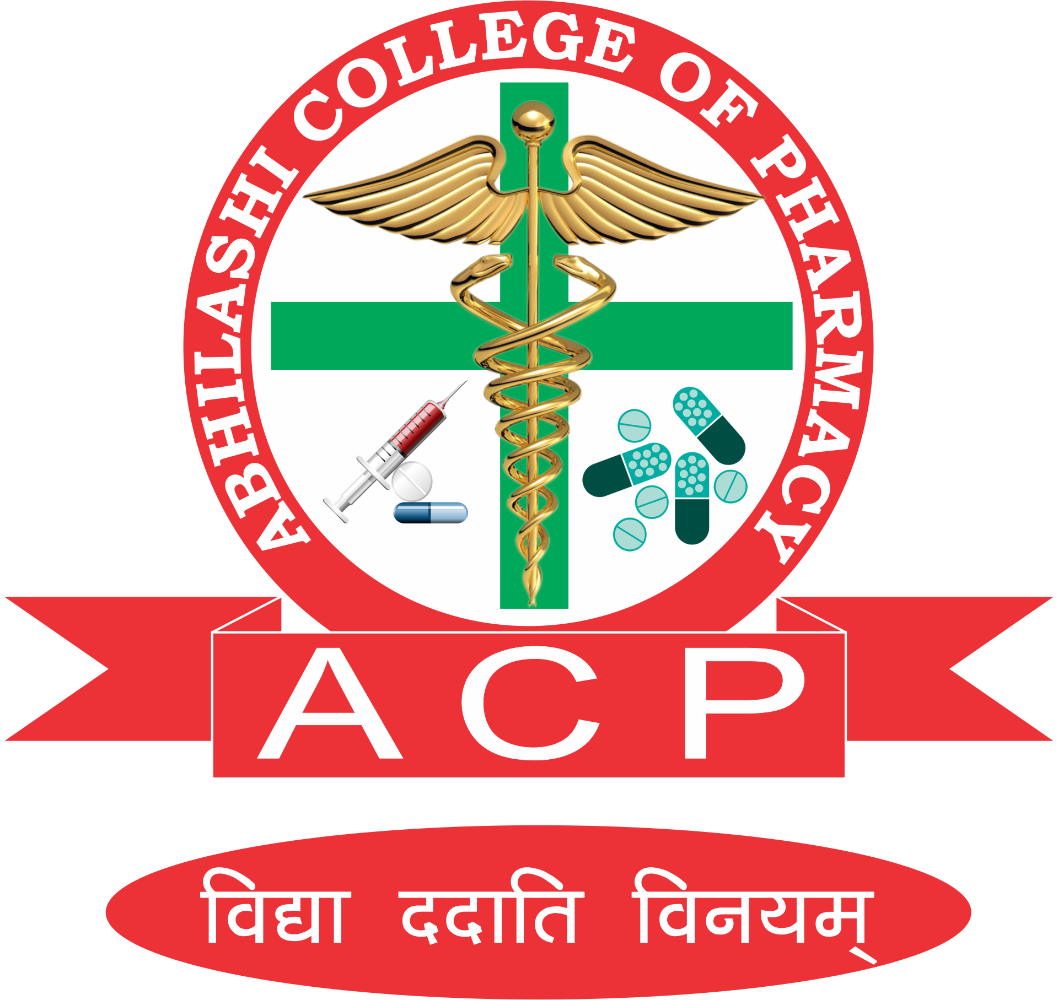
ABHILASHI COLLEGE OF PHARMACY
NER CHOWK MANDI H.P
“World Pharmacists Day” 25th September 2019
Committee members:
Registration Committee:
S.N | Name | Contact Number | E-mail address
1. | Mrs. Geetanjali Saini | 8264401169 | geetanjalisaini81@gmail.com
2. | Mrs. Shweta Saini | 8988146637 | shweta.mpharm.ss@gmail.com
3. | Miss Deepika Sharma | 9418024895 | deepikasharma.bhushan@gmail.com
4. | Mr. Anchal | 9418469511 | anchalsharma69511@gmail.com

Events organizing committee:
S.N | Events Name | Event Coordinator | Contact Number | E-mail address
1. | Declamation Competition | Mrs. Geetanjali Saini | 8264401169 | geetanjalisaini81@gmail.com
1. | Declamation Competition | Ms. Deepika Sharma | 9418024895 | deepikasharma.bhushan@gmail.com
1. | Declamation Competition | Mrs. Shweta Saini | 8988146637 | shweta.mpharm.ss@gmail.com
1. | Declamation Competition | Ms. Pooja Chauhan | 8894069936 | ibaadat746@gmail.com
1. | Declamation Competition | Ms. Nisha | 8988261885 | nishamnd92@gmail.com
2. | Quiz | Miss Pooja Sharma | 8219281319 | poojasharma195106@gmail.com
2. | Quiz | Ms. Ruma Sharma | 9805916350 | ruma90sharma@gmail.com
3. | Poster making competition | Ms. Swati | 7018903061 | sswatisharma555@gmail.com
3. | Poster making competition | Mr. Anchal | 9418469511 | anchalsharma69511@gmail.com
3. | Poster making competition | Mr. Lokesh | 8988069770
4. | Model Making competition | Mrs. Susheela Sharma | 8894473379 | susheelasharma1989@gmail.com
4. | Model Making competition | Mrs. Shivalika Thakur | 7807700538 | shivalikathakur999@gmail.com
4. | Model Making competition | Mr. Puneet
5. | Rangoli Competition | Ms. Babita Thakur | 7807668386 | babitathakur514@gmail.com
5. | Rangoli Competition | Ms. Jyoti | 9805083175 | jia.thakur21@gmail.com
5. | Rangoli Competition | Ms. Vandana | 8219896443 | vandanathakur129@gmail.com
5. | Rangoli Competition | Miss. Nisha | 8988261885 | nishamnd92@gmail.com
6. | Nukkad Natak | Ms. Kiran kumari | 8988440305 | kiranthakur738@gmail.com
6. | Nukkad Natak | Ms. Ruma Sharma | 9805916350
6. | Nukkad Natak | Mr. Puneet | 9857290078 | puneet121kaushal@gmail.com
7. | Awareness/Health Camp | Mr. Pratap | 9736995701 | psap7nv@gmail.com
7. | Awareness/Health Camp | Mr. Anchal | 9418469511 | anchalsharma69511@gmail.com
8. | Stage organising | Ms.Geetanjali | 8264401169 | geetanjalisaini81@gmail.com
8. | Stage organising | Ms.Ruma | 9805916350 | ruma90sharma@gmail.com

